**Title**

Yoshihiko Ihara1, Hideaki Obuse2,1, and Yukitoshi Motome

*1 Department of Physics, Hokkaido University, Japan*

*2Department of Applied Physics, Hokkaido University, Japan*

*3 Department of Applied Physics, The University of Tokyo, Japan*

Email: nfam@eng.hokudai.ac.jp

This is the Microsoft Word template file for an abstract for NFAM.

The preferred format is:

* Total length: 1 page
* Title: Times New Roman Bold, 18pt

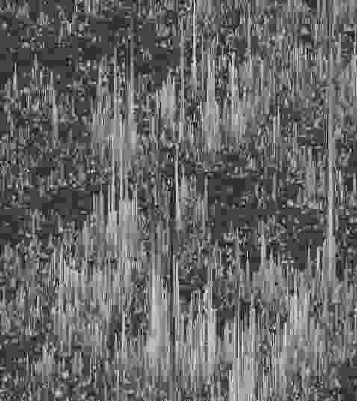

Fig.1: The figure caption.

* Authors: Times New Roman, 14pt
* Affiliations: Times New Roman Italic, 12pt
* Email: Times New Roman, 11pt
* Main text and references: Times New Roman, 12pt
* Figure caption: Times New Roman, 11pt

Please convert this file to PDF before submission. The file name should be {First name}-{Family name} of the author who gives the presentation followed by either “_Talk.pdf” or “_Poster.pdf”, depending on the type of presentation, e.g. Hideki-Hirori_Talk.pdf or Satoru-Hayami_Poster.pdf. The email address given after the list of affiliations should be that of the presenter.

[1] P. Anderson, Phys. Rev. **109**, 1492 (1958).

*For those who have a Google account,*

* please submit your abstract through the form [here](https://forms.gle/DM2Dae2XxiFwCS329).

*For those who cannot use the Google services,*

* please send the filled form and the PDF of your abstract to [nfam@eng.hokudai.ac.jp](mailto:nfam@eng.hokudai.ac.jp) by the deadline. The subject of the email should be "Abstract".In the body, please provide the following information:

-------------------------

Email address*:

First name*:

Middle name:

Last Name*:

Title*: Prof./ Dr./ Ms./ Mr.

Affiliation*:

Country of the affiliation*:

Type of presentation you prefer*: Talk/Poster

Title of your presentation*:

(*:required)

-------------------------